Strategic Plan
2020-2025
21 April 2020

Introducing Australian quadball
Australian quadball is a relatively young sport – first introduced here in 2010 and played competitively from 2011.
Initially inspired by JK Rowling’s best-selling Harry Potter series and adapted in the United States in 2005, quadball attracts people who are seeking a new experience that is interesting, strategic and fun to play, athletes and competitive sportspeople seeking new challenges and experiences, as well as fans of the series.
Quadball is the leading gender-integrated sport in Australia, uniquely recognising gender diversity in its rules and values. The sense of community is a strong feature of quadball in Australia and friendships develop across teams, states and internationally.
Our people are our greatest asset – volunteers who make things happen, govern our sport, plan and run our events, play, referee and coach.
Highlight achievements:
- Over 30 competitive teams
- World Champions 2016 – the Dropbears – Team Australia
- Video series for referee training
- New website https://www.quadballaustralia.org/ launched February 2020

Why a strategic plan?
Preparing Quadball Australia to meet the needs of quadball in Australia and advancing quadball in Australia in the next 5 years, this strategic plan lays out Quadball Australia’s vision, mission, values, strategic priorities and goals. It will guide decision-making for the national Board and state organisations, inform the development of more detailed and specific annual strategies and action items, and be held as a document of accountability that reflects the aspirations and interests of Quadball Australia’s members.

Our vision:
A sport for everyone – your goals, your place, your people

Our mission:
Enable quadball related activities, recreational or competitive, for the growth and wellbeing of individuals and the sport in Australia

Our values:
- Player growth and wellbeing
We support individuals to achieve their goals and sense of wellbeing, whether this is the ability to play competitively, become and keep fit in a supportive environment, personal improvement, knowledge and skills, mental health and social wellbeing. We provide opportunities and support for people to take on leadership and roles they may not have envisaged.
- Inclusivity
In our rules and attitudes, we are inclusive of gender, diversity and different skill levels. Our sport recognises and welcomes all genders and abilities. We can accommodate people with differing skills and personal goals.
- Player safety
We promote an environment where everyone, regardless of gender, is comfortable engaging in a full contact sport. We offer skill development and encourage safe practices.
- Quadball spirit
We encourage a spirit of collaboration on and off pitch, respect, honesty and friendship. We provide opportunities for members to contribute to the development of quadball.
- Affordability and accessibility
We value participation in fitness, sport and our quadball community and consider the affordability and accessibility of our activities.

Our strategic priorities:

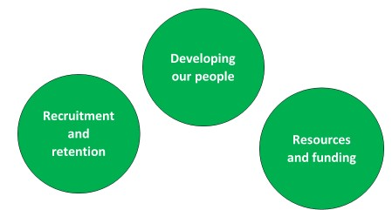

Enablers

Collaboration | Consistency | Culture
Everyone working together to deliver outcomes consistent with our values and priorities | Leadership, policies and actions that align with our strategic vision, values and priorities | Championing our quadball spirit of diversity through sport, being an inclusive and welcoming community for all genders, backgrounds and abilities

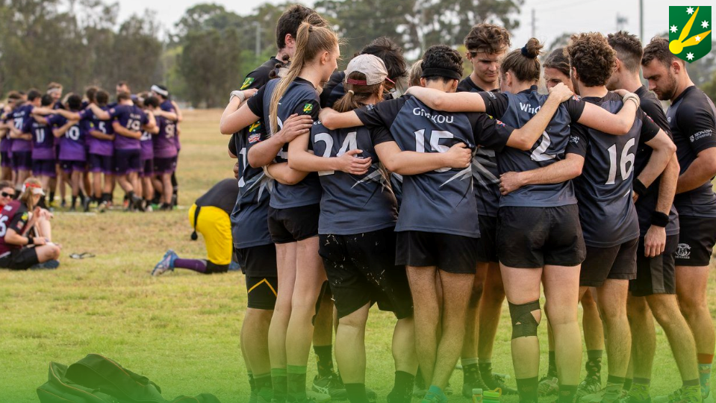

Our goals and outcomes:

 | Goals | Outcomes (NB measurable targets eg numbers may be added to some outcomes)
Recruitment and retention | Increase participation of school aged children and develop a youth league  - Provide opportunities for adults not previously involved in quadball to participate  - Strengthen links between university, graduate and community teams  - Increase the geographical spread of quadball across Australia | - Kidditch is supported and recognised as an alternative sport and fun activity for all  - Youth league is launched in each state  - Increased number of people who have experienced quadball  - Increased number of people who continue to participate in quadball across their life stage  - Increased quadball activity in rural and regional areas, within and across states
Developing our people | - Develop coaching skills and techniques  - Improve referee’s practical skills and confidence  - Further opportunities for people to engage and learn in administrative roles  - Take affirmative action for developing women in sport and leadership roles | - Safe and motivational skill development  - Increased competency and capability  - Reduced burnout  - Trust and confidence in the Board, administration and event management  - Increased number of women actively participating at all levels of competition and leadership roles
Resources and funding | - Provide clubs with resources to support grant applications  - Investigate options for sourcing and distributing funds across clubs  - Seek recognition of quadball as a sport  - Improve communication tools and marketing | - Successful grant applications  - Equitable distribution of available funds  - “Startup” clubs supported with resources, mentoring and grants  - Sport Australia recognises Quadball Australia as a National Sporting Organisation  - Timely, accessible, and clear communication  - Increased visibility of the quadball “brand“

What do we do?
Quadball Australia Incorporated (QA) is a not for profit organisation formed in 2011 and registered as an incorporated organisation, as are each of its state members. Currently, QA hosts two events each year - an interstate representative competition where state teams compete for the State Shield and the QUAFL Cup (a multi-day national championships where club teams come from across the country). QA also provides referee and snitch mentorship and certification, event sanctioning, insurance cover for members, grants for team improvement as well as organisational and administrative support to state and club members.
Regular leagues are run by the New South Wales, Victorian, Queensland and Western Australian state bodies amongst numerous open game and social events. Clubs offer social activities, as well as fitness, skills development and participation in competition leagues and events.

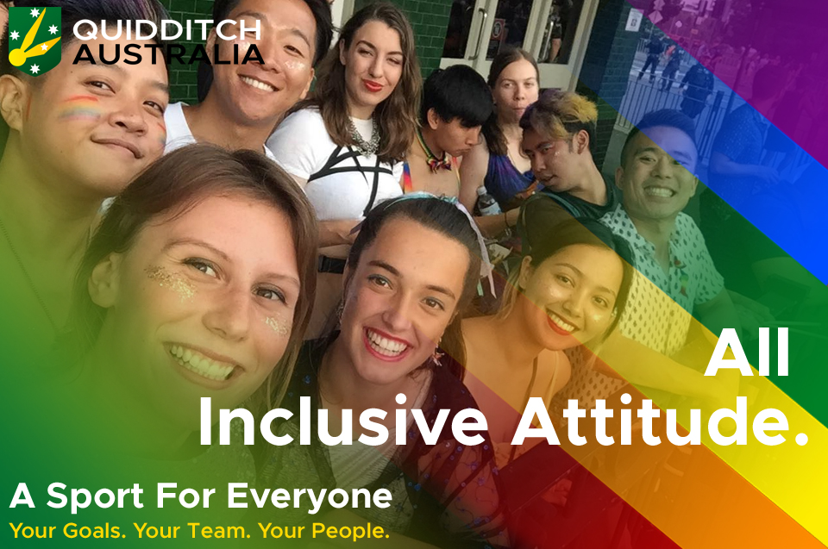

How will we improve on this?
Building on what we do, we will seek to meet our goals by exploring and encouraging initiatives that have been suggested by our members through our planning processes. Examples of these are listed against our goals below.

Recruitment and Retention

Increase participation of school aged children and develop a youth league
Initiatives:
  - Online resource guide for teachers to run quadball skills and modified games, including equipment information and how to build hoops
  - Members apply for Working for Children checks
  - Birthday parties with fee
  - Fun competition for teachers – 8 weeks or at development day
  - Youth league
  - Exhibition match at NQL with spectator commentary
  - Local council advocacy to provide hoops in parks
  - On-line presence

Provide opportunities for adults not previously involved in quadball to participate
Initiatives:
  - Corporate team building sessions
  - Join existing events eg Mardi Gras, local Council events
  - Simplified version for work lunchtime/after work activity/Christmas parties
  - Partner with clubs, businesses, schools, public service departments for recruitment
  - Demonstrations and guidelines to social sports associations and community organisations
  - Branding created, marketed and lived in each club, state and national

Strengthen links between university, graduate and community teams
Initiatives:
  - Orientation stalls and events maintained at all universities
  - University teams mentored and aided in recruitment by graduates
  - Alumni system
  - Events and media promoting social connectedness across teams
  - Pathways open to engage in different community teams
  - Quidcamp revived

Increase the geographical spread of quadball across Australia
Initiatives:
  - Administrative and organisational resources for newly established clubs
  - Support club and state members’ recruitment activities
  - Outreach to regional and rural areas

Developing our people

Develop coaching skills and techniques
Initiatives:
  - Source coach-the-coach resources from other teams and other sports to provide skill building workshops
  - Regular workshops and information on drills and coaching tips

Improve referee’s practical skills and confidence
Initiatives:
  - Formalised structure for shadow refereeing
  - Better system of referee and snitch referee certification incorporating practical and theory
  - Referees recognised at peak games (eg medals were provided at World Cup)
  - Rookie Referee of the Year Award
  - Lead assistant referee role trialed on sideline to assist Head Referee
  - Training modules eg vocalisation and confidence building following from Nat’s Webinars
  - Co-Head Referee at Fantasy tournaments

Further opportunities for people to engage and learn in administrative roles
Initiatives:
  - Resources and mentors on how to run a club well
  - Standing Committees with entry level volunteer opportunities
  - Annual strategic forum alongside Quidcamp
  - Every board member has an assistant nominated
  - Engagement with international initiatives eg Q Consultancy

Take affirmative action for developing women in sport and leadership roles
Initiatives:
  - Quadball Australia Gender Engagement Committee
  - Fantasy tournaments with female players in key roles
  - Video-based skills, drills, and strategy/practical manual on techniques for smaller-bodied players
  - Development workshops
  - Marketing of women in sport

Resources and funding

Provide clubs with resources to support grant applications
Initiatives:
  - Directory of grant opportunities
  - Guideline on how to apply for a grant
  - Successful grant applications shared

Investigate options for sourcing and distributing funds across clubs
Initiatives:
  - Partnerships between university and community teams
  - Tiered fee system
  - Equipment contribution to emerging clubs
  - Grant opportunities across local regions

Seek recognition of quadball as a sport
Initiatives:
  - Sports Association engagement at local or regional level
  - Ratified new Quadball Australia constitution that reflects vision for the development and governance of quadball in Australia and the requirements of the current Corporations Act and Sport Australia
  - Potential to transfer Quadball Australia Incorporated to a Company Limited by Guarantee in accordance with the Corporation Act (2001)
  - Recognition of Quadball Australia by Sport Australia as a National Sports Organisation
  - Continuous improvement in our corporate governance
  - Alignment with Sport Australia’s risk minimisation best practice to enhance future funding prospects and provide safe, welcoming environments
  - Recognisable brands of Quadball Australia and quadball as a sport through considered and strategic marketing

Improve communication tools and marketing
Initiatives:
  - Exhibition matches advertised for spectator engagement
  - Published annual membership and participation information to support decision-making and marketing
- Consistent branding, showcasing our professionalism
  - Marketing Strategy developed and implemented

